**11-Nov-2024**

**Internship Day - 77 Report:**

**Understanding Shell Scripting: Definition, Purpose, and Benefits**

**Definition of Shell Scripting**

Shell scripting is a method of automating tasks in Unix/Linux environments by writing a series of commands in a text file, which can be executed as a program. The "shell" refers to the command-line interface that allows users to interact with the operating system. Shell scripts can include various commands, control structures (such as loops and conditionals), functions, and variables, enabling users to create complex workflows and automate repetitive tasks.

**Purpose of Shell Scripting**

The primary purpose of shell scripting is to simplify and automate a wide range of tasks that would otherwise require manual intervention. This is particularly useful for system administrators, developers, and anyone who frequently interacts with the command line. Shell scripts can be used for:

1. **Automation:** Automating repetitive tasks like backups, file management, and system monitoring reduces the workload and minimizes the risk of human error.
2. **Task Scheduling:** Shell scripts can be scheduled to run automatically at specified times using tools like cron, allowing for regular maintenance and updates without manual effort.
3. **System Administration:** Administrators use shell scripts to manage system configurations, user accounts, and software installations, making it easier to maintain multiple systems efficiently.
4. **Batch Processing:** Shell scripts can process large volumes of data in batch mode, enabling efficient data manipulation and analysis.
5. **Environment Setup:** They can configure the environment for development or deployment, ensuring that all necessary variables and settings are in place.
6. **Integration:** Shell scripts allow for the integration of various programs and tools, facilitating complex workflows that involve multiple steps and processes.
7. **Portability:** Shell scripts are often portable across different Unix-like systems, allowing users to run them without modification on various platforms.
8. **Simplicity:** Writing shell scripts can be simpler and quicker than developing full-fledged applications, especially for straightforward tasks.

**Benefits of Shell Scripting**

1. **Efficiency:** Automating tasks saves time and increases productivity by allowing users to focus on more complex and critical issues.
2. **Consistency:** Scripts ensure that tasks are performed in a consistent manner, reducing the likelihood of errors that can occur with manual execution.
3. **Flexibility:** Users can customize scripts to fit their specific needs, making it a versatile tool for a variety of tasks.

**Cost-Effectiveness:** Shell scripting is a cost-effective solution for automating tasks without the need for expensive software tools.  
  
  
  
  
  
  
  
  
  
  
  
  
  
  
  
  
  
  
  
  
  
  
  
  
  
  
**Deploying a Website Live on an Apache Server**

**Definition of the Script File**

This shell script is designed to automate the setup of an Apache web server on a Unix/Linux system. It performs tasks such as updating the system, installing necessary packages, starting the Apache service, downloading a sample website template, and cleaning up temporary files after the installation process is complete.

**Use and Benefits:**

**Use:** This script is used to quickly and easily set up an Apache web server and deploy a sample website. It streamlines the process of installation and configuration, making it accessible even for those with limited experience.

**Benefits:**

* Time-Saving: Automates repetitive tasks so you don’t have to enter commands manually.
* Error Reduction: Reduces the chance of mistakes by executing predefined commands consistently.
* Ease of Use: Allows users to set up a web server with just a single command, making it user-friendly.
* Clean-up: Automatically removes temporary files after use, keeping the system organized.

**Input:**

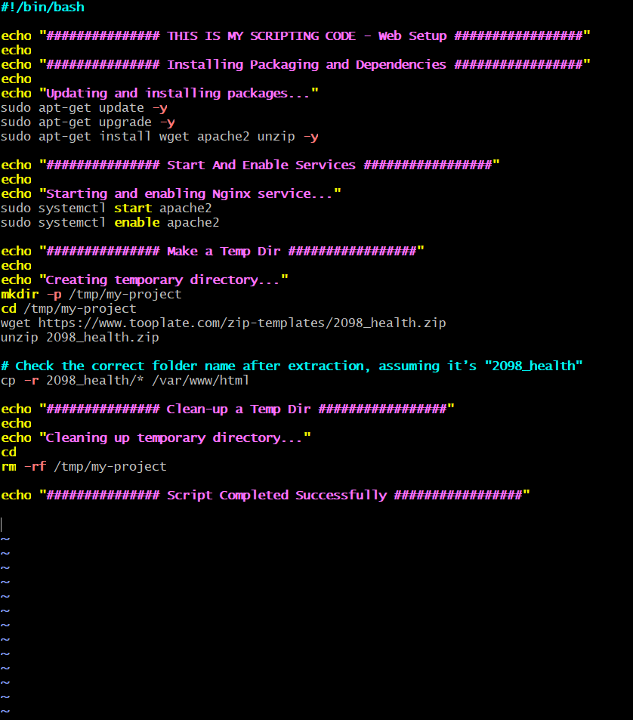  
  


**Output:**



**12-Nov-2024**

**Internship Day - 78 Report:**

**Deploying a Website Live on an NGINX Server**

**Description**

This script automates the process of deploying a static website on a server using HTTPD (Apache). It installs necessary dependencies, downloads and unzips a website template, copies the files to the web server directory, and starts the HTTPD service to make the website live.

**Use**

This script can be used to quickly set up a static website for testing or small-scale deployment. By executing it, a user can automate the installation of dependencies, deploy web files, and ensure the HTTPD service is up and running.

**Benefits**

1. **Efficiency**: Automates repetitive steps, making deployment faster.
2. **Error Reduction**: Minimizes human errors associated with manual setup.
3. **Consistency**: Ensures the same steps are followed every time, maintaining setup consistency.
4. **Convenience**: Simplifies server setup for those unfamiliar with manual deployment steps.

### Input:

### 

### 

### Output:

### 

**13-Nov-2024**

**Internship Day - 79 Report:**

**What is a Variable?**

In shell scripting, a **variable** is a named placeholder used to store data such as strings, numbers, or command outputs. Variables make scripts more dynamic by allowing the reuse of stored values and simplifying modifications.

#### **Key Features:**

1. **No Type Declaration**: Variables in shell scripting do not require data types (e.g., int, string).
2. **Assignment**: Use = for assignment without spaces around it.
3. **Access**: Retrieve the value using a $ prefix before the variable name.

**Syntax:**  
  


**Automated Website Deployment Script with Variable Assignments**

### Description

This script uses assigned variables to streamline the deployment of a static website. Variables like svc for the service name, package for required dependencies, website_url for the web template, and directory_path for the temporary storage location are defined at the beginning. This setup allows easy modification of values without needing to alter the script deeply. The script then installs necessary packages, starts and enables the HTTPD service, deploys web files from the specified URL, and cleans up temporary files after deployment.

### Use

This script is useful for automating website deployment tasks on a server with minimal effort. By defining key values as variables, it allows for easy customization of the service name, package dependencies, website template URL, and directory paths. This makes it adaptable for similar deployments where these values might need changing.

### Benefits

1. **Easy Customization**: Variables allow for quick updates to service names, URLs, or directories without modifying the entire script.
2. **Efficiency**: Automates setup steps like dependency installation and file deployment, reducing time and manual effort.
3. **Reduced Errors**: By centralizing key values in variables, the script minimizes the chance of typos or inconsistencies during configuration.
4. **Reusable**: The script can be reused across different deployments by simply adjusting variable values.
5. **Scalability**: Supports a modular approach, making it easy to add more variables if additional customization is required in future deployments.

**Input:**

**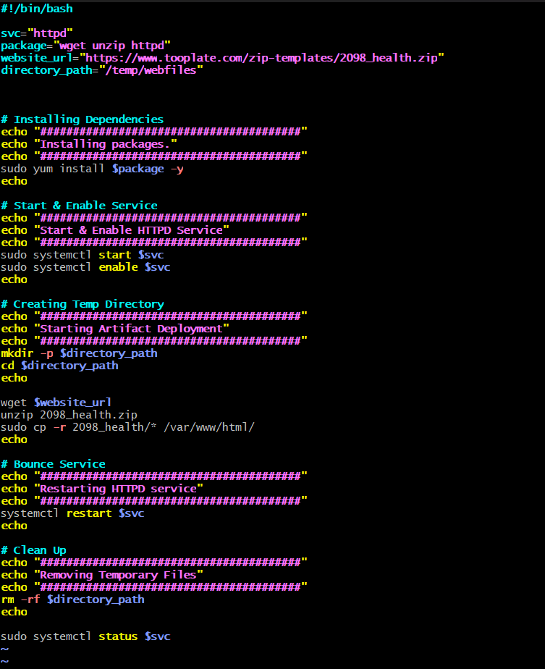  
  
**

**Output:**

### Arguments ($1 $2 $3) Mean ****Purpose****

This file is a Bash script designed to demonstrate the handling and output of positional arguments ($1, $2, etc.) in a shell script. Positional arguments allow users to pass input values to the script when it is executed.

**Contents and Functionality**

1. **Introduction Section**
   * Displays a visual separator ("~" characters) for formatting purposes.
   * Outputs the script name ($0) and the provided arguments ($1 and $2).
2. **Key Actions**
   * Prints the name of the script (stored in $0).
   * Prints the first ($1) and second ($2) arguments supplied when the script is executed.

**Input:**

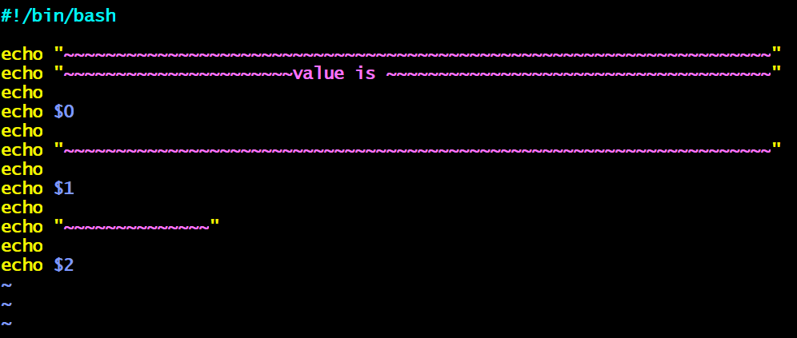

* **Command-line arguments**: The script expects two arguments to be passed when running the command.  
   **Example:**

  
  
Here, arg1 will be $1, and arg2 will be $2.

**Output**

The script displays:

1. The script name (e.g., ./arguments.sh).
2. The first argument ($1).
3. The second argument ($2).

**Example Output**:

### 

### Use Case

This script is typically used:

* To understand and debug how command-line arguments are passed to a Bash script.
* As a foundation for scripts that require user input via arguments.

**Package Installation Using User Arguments**

### ****Purpose****

This script demonstrates how to install software packages using yum (a package manager for RHEL-based Linux systems) based on user-provided arguments. The script allows flexibility to specify additional packages directly as input when executing the script.

### ****Contents and Functionality****

1. **Introduction Section**
   * Displays a message indicating that the script handles package installation using arguments.
2. **Key Action**
   * Executes the yum install command with:
     + wget (predefined package in the script).
     + Additional packages passed as arguments ($1, $2).
3. **Automatic Confirmation**
   * Uses the -y flag to automatically confirm installation prompts.

### ****Input:****

### 

* **Command-line arguments**: The script expects up to two additional package names passed when running the command.  
  **Example**:



Here:

1. package1 corresponds to $1.  
2. package2 corresponds to $2.

### ****Output:****

The script installs:

1. wget (default).

### Packages specified as arguments ($1, $2).

### 

### ****Use Case****

This script is useful for:

* Simplifying the installation of multiple packages with a single command.
* Automating installations for developers or system administrators.

**Automated Website Deployment Script Using Command-Line Arguments**

### Definition of Arguments

Arguments are values passed to a script at runtime that can be used within the script. In this script, the arguments are represented by $1, $2, and $3, which allow dynamic input for specific actions. Here, they correspond to the URL to download ($1), the file to unzip ($2), and the directory path to copy ($3).

### Why We Use Arguments

Arguments make scripts flexible and reusable by allowing the user to specify different values each time the script runs. This avoids hardcoding and makes the script adaptable for various use cases without modification.

### Use of the Script

This script automates the process of downloading, unzipping, and copying web files to the server’s root directory by accepting URL, file, and directory as command-line arguments. This is especially useful for deploying different web applications or versions of a site on the same server setup.

### Benefits

1. **Flexibility**: The script can handle various inputs, allowing it to be used with different URLs, files, and directory paths.
2. **Reusability**: The use of arguments makes it easy to reuse the script for different deployments without editing the code.
3. **Efficiency**: Speeds up deployment by automating dependency installation, file handling, and server setup.
4. **Reduced Maintenance**: Minimal changes are needed for new deployments, simplifying script maintenance and reducing the risk of errors.

**Input:**

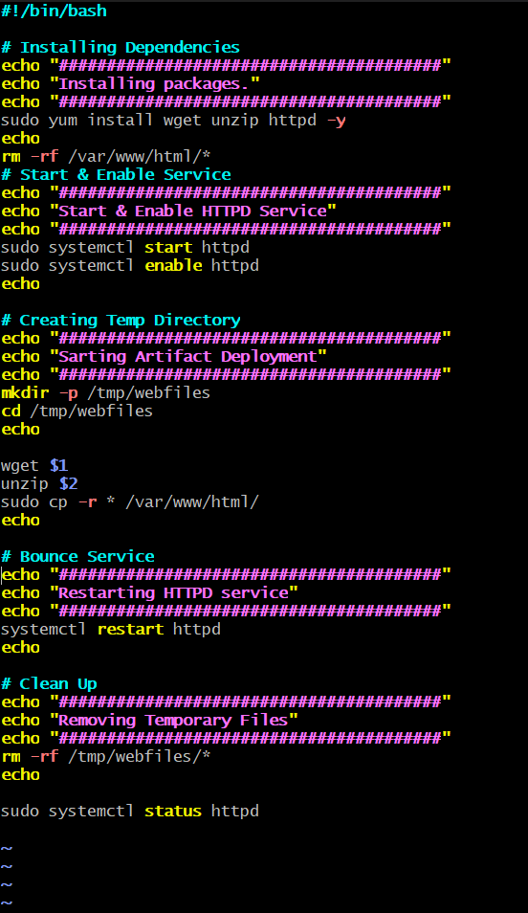



**Output:**



**14-Nov-2024**

**Internship Day - 80 Report:**

**Understanding Variables in Shell Scripting**

### ****Definition****

In shell scripting, variables are used to store data and reuse it throughout the script. This script demonstrates:

1. **Standard Variable Substitution**: Prints the value of a variable ($a).
2. **Literal Output of Variable Name**: Shows how to prevent variable substitution using single quotes or escape characters.

**Example Breakdown**:

* a="chandan" assigns the string "chandan" to the variable a.
* "Your Name is $a" displays the value of a.
* 'Name is $a' treats $a as plain text.
* "Your Name is \$a" uses the escape character (\) to print $a literally.

**INPUT:**

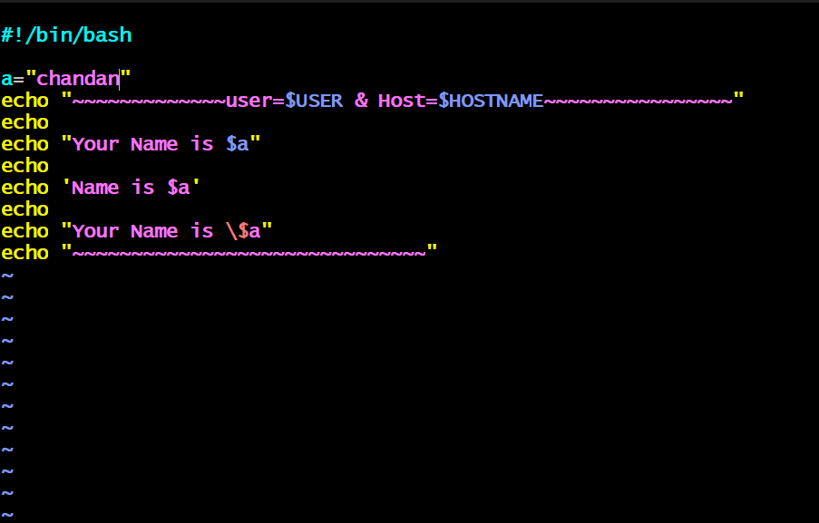



**OUTPUT:**



**Using if Conditions in Shell Scripting**

### ****Introduction****

This script demonstrates the use of the if condition in shell scripting to compare two user-provided values. By reading inputs and applying a conditional check, it determines whether the values are equal or one is greater than the other, showcasing decision-making capabilities in shell scripts.

### ****Use****

This script is useful for comparing two numerical inputs and performing conditional operations based on their values. It can be adapted for scenarios such as:

1. **Equality Checks**: Determine if two user-provided values are the same.
2. **Decision Making**: Execute specific commands or display messages based on the result of a comparison.
3. **Input Validation**: Useful in scripts where user inputs need to be compared or evaluated for further processing.

**Input:**

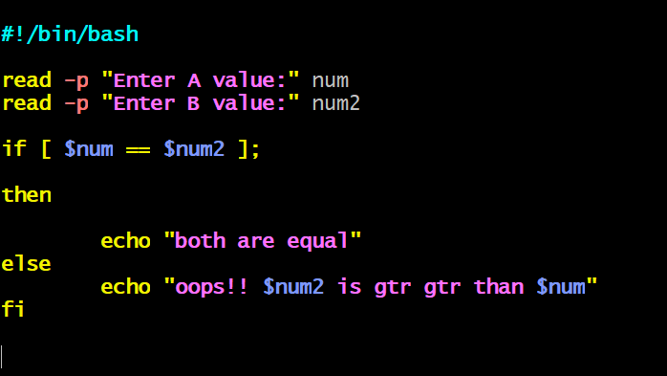



**Output:**



**Runtime Inputs in Shell Scripting**  
  
The uploaded file contains a shell script demonstrating how to handle runtime inputs in bash scripting. It shows the use of various read commands to capture user inputs, such as names, age, and gender, both with and without masking sensitive input.

### ****Uses of Runtime Inputs in Shell Scripting****

1. **Interactive Applications**: Enables scripts to interact with users during execution.
2. **Dynamic Behavior**: Allows a script to adapt its behavior based on user-provided data.
3. **Data Collection**: Useful for capturing user-specific data like credentials, preferences, and configurations.
4. **Automation**: Facilitates parameter input for automating tasks without hardcoding values.

### ****Benefits of Using Runtime Inputs****

1. **Flexibility**: Eliminates the need to modify scripts for different inputs, making them reusable.
2. **User-Centric**: Increases script usability by allowing real-time user interaction.
3. **Enhanced Security**: Using masked inputs (e.g., read -sp) ensures sensitive data, like passwords, is not displayed on the screen.
4. **Ease of Debugging**: Simplifies testing by allowing varied inputs during runtime

**Input:**

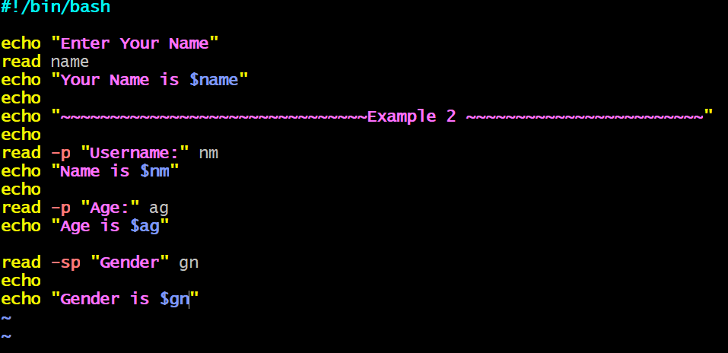



**Output:**

